LAB 08
UART Communication



Spring 2026
Embedded Systems Lab

Submitted By: MARYAM ZAMAN
Registration No: 22PWCSE2153
Class Section: B

Submitted to:

Engr. Muhammad Shahzad

May 3, 2026

Department of Computer Systems Engineering
University of Engineering and Technology

LAB 08

Universal Asynchronous Reciever Transmitter
It is a hardware communication protocol used for serial data exchange between devices, such as microcontrollers, sensors, GPS modules, and computers.
Asynchronous – No shared clock signal; devices agree on a preset baud rate (e.g., 9600, 115200 bits per second).
Uses two data lines:
TX (transmit) – sends data from one device to another’s RX.
RX (receive) – receives data from another device’s TX.
Data format – A start bit, 5–9 data bits (usually 8), optional parity bit (for error detection), and 1–2 stop bits.
Typical use:
Uploading code to Arduino/ESP32 via USB-UART bridge.
Logging debug messages to a PC terminal (e.g., PuTTY, serial monitor).
Connecting GPS receivers, Bluetooth modules (HC-05), or RFID readers.

KEY CONCEPTS
BUAD RATE:
Definition: The speed at which data is transmitted over a serial link, measured in symbols per second. In UART, one symbol is typically one bit, so baudrate ≈ bits per second (bps).
Examples: 9600, 115200 baud.
Why it matters: Both devices must use the same baudrate (e.g., 9600). If they mismatch, received data will be garbage.
>the longer the distance the smaller the baud rate.

FULL DUPLEX:
Definition: Simultaneous two-way communication. Data can be sent and received at the same time.
How UART does it: Uses separate lines – TX (transmit) and RX (receive). Device A’s TX connects to Device B’s RX, and A’s RX connects to B’s TX. This allows both sides to talk without waiting.

REGISTERS:
UBRR (baud rate register
Formula: UBRR=(F_CPU/16*Baud))-1

UCSR0B
RxENO . enable receiver
TxENO . enable transmitter

UCSR0C
Sets data format (8 bit, parity, stop bits)

UBR0
Data register(send/receiver)

TASK1
Send your names continuously on UART
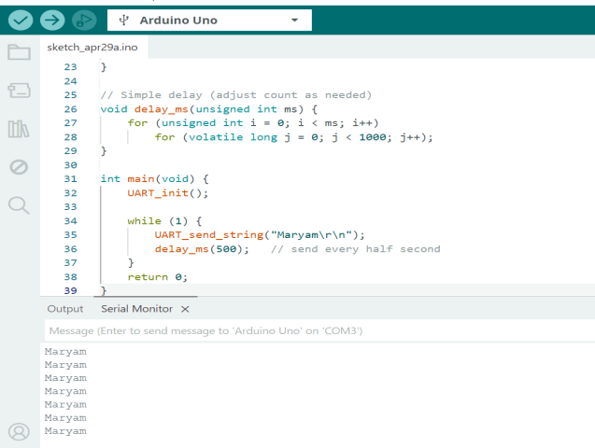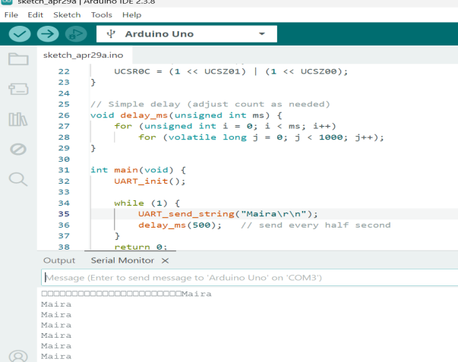

TASK2
Create echo system (whatever user types, sends back)
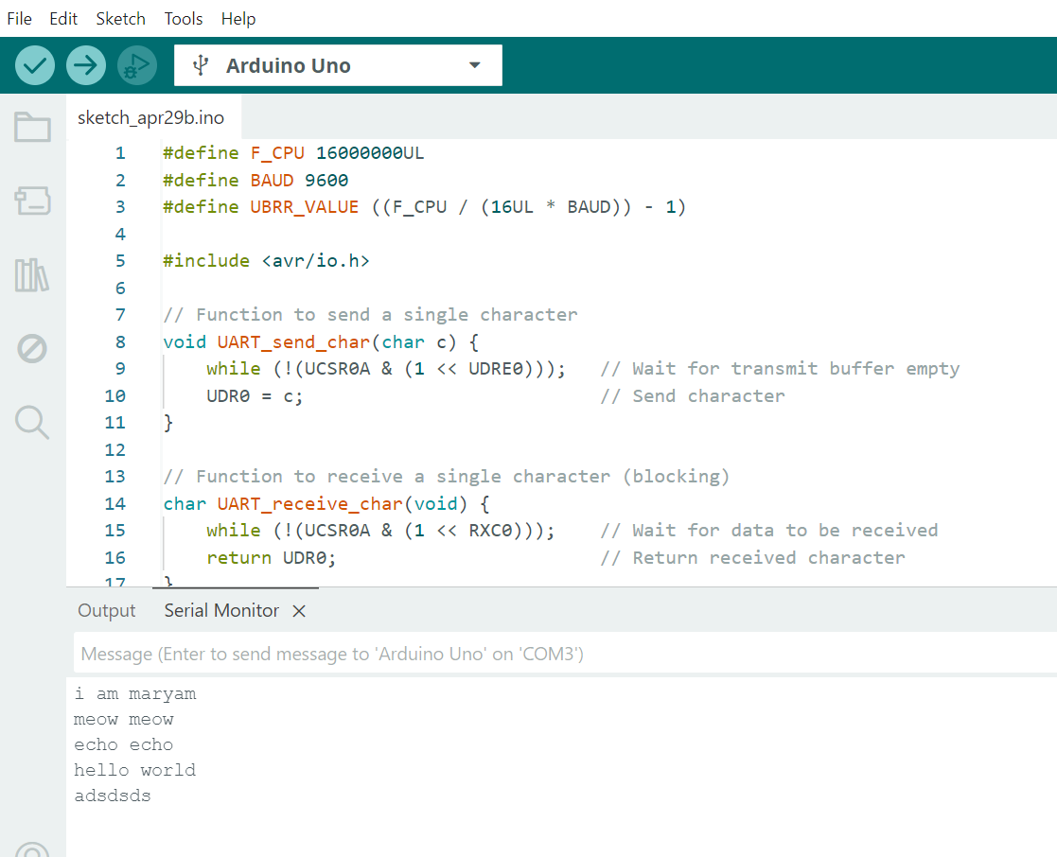

TASK3
Control LED/Buzzer using serial communication 0=off and 1= on
